Display No 1 Display No 2

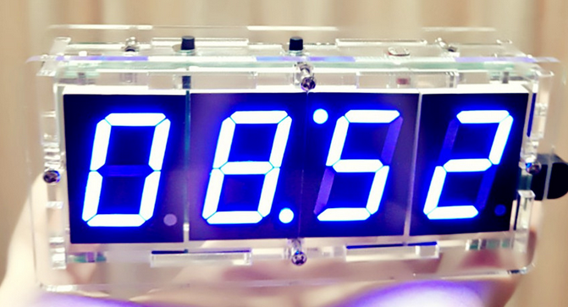

1. Press button No. 1 and the display area of ​​No. 2 flashes: It means that the minute can be adjusted. At this time, press the No. 2 button to adjust the minute
2. Press button No. 1 again, the display area of ​​No. 1 flashes: It indicates that the hour can be adjusted. At this time, press the No. 2 button to adjust the hour.
- Press button 1 again, the display area of ​​No. 2 flashes: It means that the minute of the alarm can be adjusted. At this time, press the 2 button to adjust the alarm minute.

- Press button No. 1 again, the display area of ​​No. 1 flashes: It means that the alarm hour can be adjusted, press the 2 button to adjust the alarm hour.
- Press button No. 1 again. No. 1 display area and No. 2 area will display either all 1s or all 0s. At this time, press 2 button to turn on the light control or off (the light control is the display that can change the display brightness according to the ambient light intensity).

6. Press the No. 1 button again. The No. 1 display area and the No. 2 area either display all 1s or display all 0s. At this time, press the 2nd button to turn the alarm function on or off.

7. Press button 1 again to return to the normal display interface.
8. When the alarm goes on, press the 2 button to turn off the alarm.

